SRH TRAINING INFORMATION FOR HEALTH PROFESSIONALS

The Grampian Sexual & Reproductive Health Service offers a range of training events and supports practical training for health care professionals in both primary and secondary care; including doctors, nurses, pharmacists, physician associates and nursing and medical students.

TRAINING EVENTS
We organise and coordinate regular updates and events in Sexual and Reproductive Health:

PRACTICAL TRAINING
We offer practical training for the delivery of a range of SRH services, particularly Long-Acting Reversible Contraception (LARC), including:
- The College of Sexual and Reproductive Healthcare Diploma (DCoSRH)
- The CoSRH Letter of Competence in Subdermal Implant Insertion/Removal
- The CoSRH Letter of Competence in Intrauterine Contraception
- The NHS Grampian Certificate for Implant Insertion/Removal
- The NHS Scotland Subdermal Implant Training for insertion post-pregnancy

The flowchart below displays the SRH training options currently available within Grampian SRH for health care professionals, who are interested in delivering Sexual and Reproductive Health advice, including LARC.

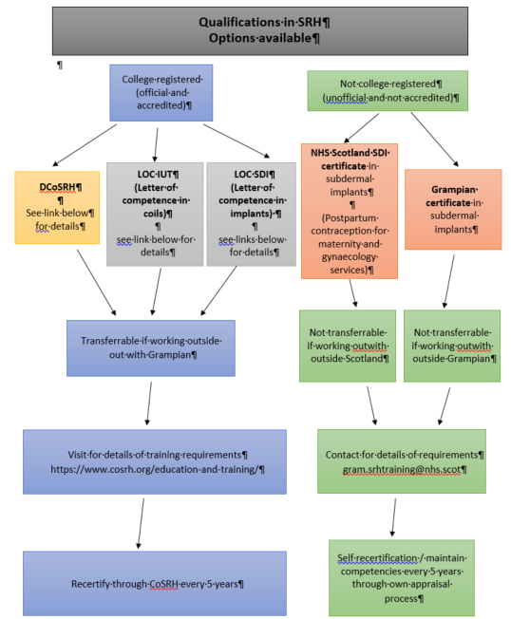

Contraceptive Subdermal Implant Training

Contraceptive Implant training will provide trainees with the necessary knowledge, attitudes and skills to support women seeking contraception. Trainees will be trained in the Insertion and Removal of subdermal implants and how to manage any complications and side effects that may occur.

Trainees have three options for implant training, which are detailed below, and they should submit an implant training request to gram.srhtraining@nhs.scot, so that progress with submitting pre-requisites can be monitored and offering practical training sessions can be organised. Practical sessions can only be organised once the trainee has completed the relevant pre-requisites.

CoSRH LOC SDI TRAINING:
This is the ‘gold standard’ option for implant training. Trainees usually complete practical training over 2-3 sessions in implant insertion and removal.
https://www.cosrh.org/Public/Public/Education-and-Training/letter-of-competence-subdermal-implants-loc-sdi.aspx
Training pre-requisites are detailed as follows:

1. CoSRH Online Theory Assessment (OTA, previously called the EKA) exam (if you do not hold a current DCoSRH).
2. CoSRH Contraceptive Counselling Course (if you do not hold a current DCoSRH).
3. e-LfH SRH Module 14 ‘Additional training in subdermal contraceptive implants’ (formerly SRH Module 17) (completed/refreshed within the last six months - free for NHS staff to register: www.e-lfh.org.uk)
4. Level 3 safeguarding children/young people (see 'Public Protection' on Turas Learn/e-LFH modules/normally done within every 3 years)
5. Level 2 safeguarding adults (see 'Public Protection' on Turas Learn/e-LFH modules/normally done within every 3 years)
6. Basic Life Support training (in-date/not expired/normally done every 12 months).
7. Anaphylaxis training (in-date/not expired/normally done every 12 months)

Training certificates must be submitted to gram.srhtraining@nhs.scot before training sessions will be allocated. This training has practical training session fees associated with it, of around £250, depending on the trainee’s circumstances.

NHS GRAMPIAN CERTIFICATE FOR IMPLANTS TRAINING:
This training is ONLY for use by those working within NHS Grampian, NHS Shetland and NHS Orkney. The certificate provided is not relevant for provision of implant services out-with these areas.

Trainees usually complete practical training over 2-3 sessions in implant insertion and removal. Training pre-requisites are detailed as follows:

1. e-LfH SRH Module 14 ‘Additional training in subdermal contraceptive implants’ (formerly SRH Module 17) (completed/refreshed within the last six months - free for NHS staff to register: www.e-lfh.org.uk)
2. Level 3 safeguarding children/young people (see 'Public Protection' on Turas Learn/e-LFH modules/normally done within every 3 years).
3. Level 2 safeguarding adults (see 'Public Protection' on Turas Learn/e-LFH modules/normally done within every 3 years).
4. Basic Life Support training (in-date/not expired/normally done every 12 months).
5. Anaphylaxis training (in-date/not expired/normally done every 12 months) and one of the following options:
6. At least ONE of the following:
- DCoSRH (renewed every 5 years)
- CoSRH Contraceptive Counselling Course (within the last 2 years).
- Completion of relevant e-Learning for Health (e-LFH) modules (1-4, 10 & 11) (within the last 2 years).
- Attendance at CoSRH 'Essentials' for Primary Care or Midwives course (within the last 2 years).
- Attendance at Local 'Introduction to Sexual Health course (within last 2 years).

Training certificates must be submitted to gram.srhtraining@nhs.scot before training sessions will be allocated. This training is a no cost option.

NHS SCOTLAND SDI TRAINING:
This training is ONLY for those working in maternity and gynaecology services to train to insert implants after pregnancy (postpartum / following abortion / miscarriage etc).

1 or 2 practical training sessions is usually sufficient to obtain competency in insertion of implants. Training pre-requisites are detailed as follows:

1. Fully registered nurse/midwife/doctor currently working in Maternity or Gynaecology setting.
2. Basic Life Support training certificate (in-date/not expired).
3. Anaphylaxis training certificate (in-date/not expired).
4. Completion of e-learning for health (e-LfH) SRH module 14:
‘Additional training in subdermal contraceptive implants’ (free for NHS staff to register: www.e-lfh.org.uk)
5. Completion of at least ONE of the following:
- e-Learning for Health modules 1-4, 10 and 11
- attendance at CoSRH ‘Essentials’ for primary care or midwives course
- for those working in maternity services – completion of NHS LearnPro training module in ‘Postpartum Contraception’ OR Turas Learn eLearning module in ‘Postpartum Contrception’.

Training certificates must be submitted to gram.srhtraining@nhs.scot before training sessions will be allocated. This training is a no cost option.

Intrauterine Contraception (coils) Training:

Trainees have only one option for intrauterine contraceptive training (there is no equivalent NHS Grampian Certificate available), detailed below. A training request should be sent promptly to gram.srhtraining@nhs.scot, so that progress with submitting pre-requisites can be monitored and offering practical training sessions can be organised. Practical sessions can only be organised once the trainee has completed the relevant pre-requisites.
CoSRH LOC IUT TRAINING:
This training has been developed to support women with contraceptive choices and access LARC provision within the UK, particularly in primary care and women’s services settings, and trainees are trained in both coil insertion and removal training over 5 or 6 practical training sessions.
https://www.cosrh.org/Public/Education-and-Training/letter-of-competence-intrauterine-techniques-loc-iut.aspx
Training pre-requisites are detailed as follows:

1. CoSRH Online Theory Assessment (OTA, previously called the EKA) exam (provided you do not hold a current DCoSRH).
2. CoSRH Contraceptive Counselling Course (provided you do not hold a current DCoSRH).
3. e-LFH SRH Module 15 (formerly eSRH Module 18) ‘Additional Training in Intrauterine Contraception’ (completed/refreshed within the last six months - free for NHS staff to register: www.e-lfh.org.uk .
4. Level 3 safeguarding children/young people (see 'Public Protection' on Turas Learn/e-LFH modules/normally done within every 3 years)
5. Level 2 safeguarding adults (see 'Public Protection' on Turas Learn/e-LFH modules/normally done within every 3 years)
6. Basic Life Support training (in-date/not expired/normally done every 12 months).
7. Anaphylaxis training (in-date/not expired/normally done every 12 months)

Training certificates must be submitted to gram.srhtraining@nhs.scot before training sessions will be allocated. This training has practical training session fees associated with it, of around £250, depending on the trainee’s circumstances.

DCoSRH Training:

The CoSRH Diploma (DCoSRH) is the gold standard of SRH training available, but it does not include the LOC IUT and LOC SDI training to become implant and coil fitters, which need to be completed independently of the DCoSRH.
The DCoSRH requires a considerable amount of self-study time and has a number of different components to it. This is detailed on the CoSRH website, (https://www.cosrh.org/Public/Public/Education-and-Training/diploma.aspx) and we have also created a PowerPoint presentation to detail the training journey for a local trainee, which will be provide, upon request.

DCoSRH trainees are asked NOT TO APPLY FOR THE DCoSRH until they have completed the pre-requisites and have been allocated a CoSRH Registered Trainer. There is a two year deadline for completion of the DCoSRH.

Trainees interested in the DCoSRH, must submit a DCoSRH training request to gram.srhtraining@nhs.scot so that progress with submitting pre-requisites can be monitored, prior to a CoSRH Registered Trainer being assigned to supervise the trainee, and practical training sessions are offered.

Training pre-requisites in NHS Grampian for the DFSRH are detailed as follows:

1. Be registered with a UK or Irish medical professional regulatory body.
2. Able to give an IM injection.
3. Able to give a sub-cutaneous injection.
4. Able to perform a speculum examination.
5. Basic Life Support training (within last year).
6. Anaphylaxis training (within last year).
7. CoSRH Online Theory Assessment (OTA, previously called the EKA) exam (passed within last two years).
8. eSRH Modules 1 to 15 (within the last two years).

Training certificates must be submitted to gram.srhtraining@nhs.scot before training sessions will be allocated. This training has practical training session fees associated with it, of around £250, and where applicable, local Assessment Half Day fees of around £200, depending on the trainee’s circumstances.

Graduate Certificate Training:

The Sexual and Reproductive Health Service supports nurses undertaking this training, but it is organised by Glasgow Caledonian University.

BSc/BSc (hons) Professional Studies in Nursing: The Theory of Sexual and Reproductive Health Module is a standalone module or can be taken as part of the Clinical Nurse Specialist Graduate Certificate within BSc/BSc (Hons) Professional Studies in Nursing Programme at Glasgow Caledonian University (see flyer below)

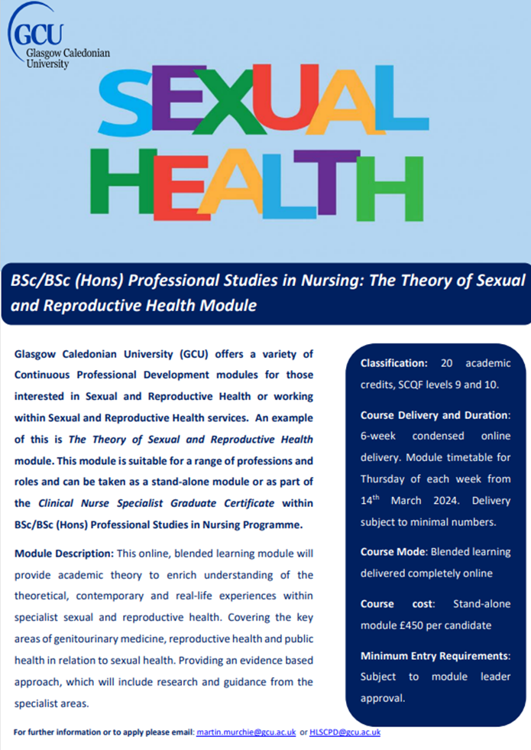

USEFUL INFORMATION:

e-Learning for Health (e-LFH) modules/eSRH modules (register for free):
https://www.e-lfh.org.uk/programmes/sexual-and-reproductive-healthcare/

Turas Learn – Postpartum Contraception eLearning Module (you must be logged in for link to work):
https://learn.nes.nhs.scot/75618/postpartum-contraception/postpartum-contraception

Video for Coil Removal:
https://www.cosrh.org/Public/Public/Education-and-Training/cosrh-bitesize-intrauterine-device-iud-removal.aspx

College of Sexual and Reproductive Healthcare (CoSRH) Guidelines and Statements:
https://www.cosrh.org/Public/Public/Standards-and-Guidance/cosrh-guidelines-and-statements.aspx

UK Medical Eligibility Criteria for Contraceptive Use (UKMEC) Standards and Guidance:
https://www.cosrh.org/Public/Public/Standards-and-Guidance/uk-medical-eligibility-criteria-for-contraceptive-use-ukmec.aspx

BASHH STI and HIV eLearning- free additional resources focused on STI and HIV knowledge:
https://www.e-lfh.org.uk/programmes/sexual-health-and-hiv/

National HIV Nurses Association (NHIVNA) resources – nurses can also register for free and complete HIV eLearning modules:
https://www.nhivna.org/login

